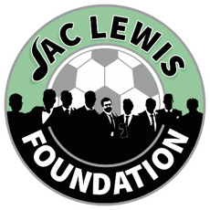

  - City Cluster Counselling Service
  - FREE Anxiety Workshop
- We understand that each person's experience with anxiety is unique, and our goal is to offer personalized strategies and tools that cater to your specific needs.
- During our workshop, you will be surrounded by individuals who share similar experiences, fostering a sense of community and understanding.
- Our expert facilitators will guide you through a series of interactive sessions that include mindfulness practices, cognitive-behavioural techniques, and stress management exercises.
- These sessions are designed to equip you with practical skills that you can apply in your daily life to help reduce anxiety and improve your overall well-being.

19th August 2024 10-12pm
Online - Via Zoom
To book onto the workshop please:
Email Admin@jaclewisfoundation.co.uk
Call or Text 03301336510

